Title off the project:

NEUROFLEETX – AI POWERED URBAN FLEET AND TRAFFIC INTELLIGENCE SYSTEM

Submitted by:
Pamala Dinesh Kumar,
Team-B.

Under the Guidance of:
Vinay Prashanth.

Contents Page
CONTENTS Page No.

1. Abstract 3
2. Introduction 4
3. Problem Definition 5
4. Objectives of the Project 6
5. Scope of the Project 7
6. System Architecture 8
7.Roles and Responsibilities 9
8. Requirements 10
9. Modules Description 11
10.Software Requirements 12
11. Advantages and limitations 14
12. Future Enhancements 15
13.Conclusion 16
14. Appendix 17

Abstract

Urban transportation systems demand efficient fleet management and continuous traffic monitoring to minimize operational inefficiencies, reduce safety risks, and improve overall service reliability. However, traditional fleet management solutions are often limited by the absence of real-time intelligence, poor scalability, and a lack of data-driven decision support mechanisms.
NeuroFleetX is an AI-powered urban fleet and traffic intelligence system developed to address these limitations through a centralized, web-based platform. The system enables comprehensive management of drivers, vehicles, and trips while providing role-based access control for administrators, managers, and drivers to ensure secure and structured system usage.
NeuroFleetX incorporates real-time monitoring features along with artificial intelligence-based analytics to analyze operational data, identify patterns, and support informed decision-making. The platform is designed using modern full-stack technologies, ensuring scalability, modularity, and secure data handling.
The primary objective of this project is to deliver a robust, intelligent, and scalable solution capable of enhancing operational efficiency, improving traffic awareness, and supporting smart urban transportation management. This system demonstrates how emerging technologies can be effectively applied to solve real-world challenges in urban mobility and fleet operations.

Introduction

Rapid urbanization has increased the complexity of transportation systems and fleet operations. Traditional fleet management methods often lead to inefficient vehicle utilization, lack of real-time monitoring, and higher operational costs, making them unsuitable for modern urban environments.
Modern transportation systems require intelligent automation, real-time data processing, and secure access mechanisms. The use of Artificial Intelligence (AI) enables predictive analysis and data-driven decision-making, improving efficiency and safety.
NeuroFleetX is developed as an AI-powered, web-based fleet and traffic management system that provides centralized control of drivers, vehicles, and trips with role-based access control. By integrating real-time monitoring and AI-driven analytics, the system enhances operational efficiency and supports smart urban mobility.

Problem Definition

Existing fleet management systems suffer from several limitations, including lack of real-time vehicle tracking, insufficient traffic analysis, and weak security mechanisms. These systems often rely on manual coordination between drivers, vehicles, and administrators, which increases the possibility of human errors, communication gaps, and operational delays. As fleet size grows, managing operations manually becomes increasingly inefficient and unreliable.
Additionally, the absence of intelligent analytics and predictive capabilities restricts the system’s ability to identify potential risks, optimize route planning, and improve resource utilization. Without data-driven insights, decision-making remains reactive rather than proactive, leading to higher operational costs and reduced safety.
Therefore, there is a strong need for an automated, intelligent, and scalable fleet management system that integrates real-time monitoring, secure access control, and AI-driven analytics to support efficient, safe, and reliable urban transportation operations.

OBJECTIVES OF THE PROJECT

Main Objectives:
- To design and develop an intelligent fleet and traffic management system suitable for urban transportation environments.
- To automate the management of drivers, vehicles, and trip operations through a centralized platform.
- To implement secure role-based authentication and authorization mechanisms to ensure controlled system access.
- To integrate artificial intelligence-based analytics for performance evaluation, risk prediction, and decision support.
- To enhance operational efficiency, safety, and resource utilization in fleet management operations

SCOPE OF THE PROJECT

Scope:
The scope of this project encompasses the design and implementation of an intelligent fleet and traffic management system that facilitates efficient handling of core fleet operations. The system includes functionalities for driver allocation, vehicle monitoring, and trip tracking through a centralized, web-based platform.
The project supports role-based access control for different user roles such as administrators, managers, and drivers, ensuring secure and authorized access to system functionalities. Each role is provided with predefined permissions aligned with operational responsibilities.
Additionally, the scope includes the integration of AI-based analytics and traffic intelligence to analyze operational data, identify patterns, and support informed decision-making. The system is designed to be scalable and modular, allowing future enhancements such as advanced predictive models, real-time alerts, and integration with external data sources.
.

SYSTEM ARCHITECTURE

The architecture of NeuroFleetX is based on a layered architectural model. The Presentation Layer provides an interface for user interaction and role-based access. The Application Layer contains the core business logic responsible for processing user requests and managing system operations.
The Data Access Layer handles data storage and retrieval, ensuring data consistency and persistence. The Security Layer enforces authentication and authorization mechanisms, protecting system resources from unauthorized access.
This architectural approach improves modularity, scalability, and maintainability of the system.
PRESENTATION LAYER

APPLICATION LAYER

DATA ACCESS LAYER

SECURITY LAYER

ROLE IN THE PROJECT

Role and Responsibility:

The author of this project was primarily responsible for the design and development of the Driver Management module within the NeuroFleetX system. This included modeling driver-related entities, defining relationships with vehicles and trips, and implementing role-based access control to ensure secure and authorized system usage.
The responsibilities also involved integrating the driver module with vehicle and trip management functionalities to enable seamless operational workflows. Additionally, the author conducted functional testing of the implemented features to validate system behavior and ensure reliability.
Furthermore, attention was given to secure data handling practices, including validation and access restrictions, to maintain data integrity and system security throughout the driver management operations.

FUNCTIONAL REQUIREMENTS

Functional Requirements:
- The system shall provide user authentication and authorization using role-based access control to ensure secure access for administrators, managers, and drivers.
- The system shall support driver and vehicle management, including registration, assignment, and status tracking.
- The system shall enable trip monitoring and status updates, allowing real-time tracking of trip progress and operational states.
- The system shall generate analytical reports to support operational analysis and decision-making.
NON-FUNCTIONAL REQUIREMENTS
- Security: The system shall ensure secure data access, authentication, and protection against unauthorized usage.
- Scalability: The system shall be capable of handling an increasing number of users, vehicles, and trips without performance degradation.
- Performance: The system shall respond efficiently to user requests and support real-time monitoring operations.
- Reliability: The system shall provide consistent and accurate functionality with minimal system failures.
- Maintainability: The system shall be modular and well-structured to allow easy maintenance and future enhancements.

Module Description

Dashboard
The dashboard presents a visual overview of fleet operations, displaying key metrics such as active trips, available drivers, and vehicle status. It assists managers and administrators in real-time monitoring and decision-making.
Create Trip
This functionality allows authorized users to create a new trip by assigning a driver and vehicle, along with source and destination details. The system records trip start time and status, enabling effective trip monitoring.
Manual Driver Check-In
The manual driver check-in feature enables drivers to confirm availability before trip assignment. This helps administrators verify driver readiness and maintain accurate operational status.
Trip Summary
The trip summary provides a consolidated view of trip details, including route information, duration, status, and performance metrics. This feature supports operational analysis and record maintenance.

Software Requirements
Backend Technologies
- Spring Boot – Used for developing RESTful backend services and managing application configuration in a modular and scalable manner.
- Spring Security – Implements authentication, authorization, and role-based access control to ensure secure system access.
- Spring Data JPA – Handles object-relational mapping and simplifies database operations through entity-based data persistence.
- JWT (JSON Web Token) – Used for secure, stateless authentication and session management across the application.
Frontend Technologies
- React.js – Used to build a responsive, component-based user interface for efficient user interaction and dynamic data rendering.
- Tailwind CSS – Used for styling the user interface through utility-first CSS classes, enabling rapid development and consistent design.
- Axios – Facilitates HTTP communication between the frontend and backend services for data exchange.
Database
- PostgreSQL – Used for persistent storage of user, driver, vehicle, and trip-related data, ensuring data consistency and reliability.

Third-Party APIs Used
- OpenStreetMap (OSM) – Integrated to provide map visualization and location-based support for displaying routes, locations, and trip-related geographical information. The use of OSM enables cost-effective and open-source map integration within the system.

Advantages & Limitations

Advantages
- Automated fleet operations reduce manual intervention and minimize operational errors.
- Improved decision-making is achieved through analytical insights and data-driven reporting.
- Enhanced security through role-based authentication and controlled access mechanisms.
- Reduced manual effort increases efficiency and allows better utilization of human resources.

Limitations

Despite its advantages, the system has certain limitations. The platform is dependent on stable internet connectivity, which may affect real-time functionality in low-network environments. Additionally, the current implementation supports limited real-time tracking capabilities. Advanced predictive and optimization models are constrained in the present version and are planned for future enhancement.

FUTURE ENHANCEMENTS

- Mobile application support to enable real-time access for drivers and managers through smartphones, improving usability and operational responsiveness.
- Advanced AI prediction models to enhance risk assessment, traffic forecasting, and operational optimization using historical and real-time data.
- Cloud deployment to improve system scalability, availability, and performance while supporting large-scale fleet operations and data storage.

CONCLUSION

NeuroFleetX provides an effective and intelligent solution for urban fleet and traffic management. By integrating automation, secure role-based access, and artificial intelligence, the system successfully addresses the key limitations of traditional fleet management approaches. The platform enhances operational efficiency, supports informed decision-making, and improves overall system reliability.
Furthermore, the modular and scalable design of NeuroFleetX offers a strong foundation for future enhancements, including advanced analytics, mobile integration, and cloud deployment. This project demonstrates the practical application of modern full-stack technologies and AI techniques in solving real-world urban transportation challenges.

Appendix

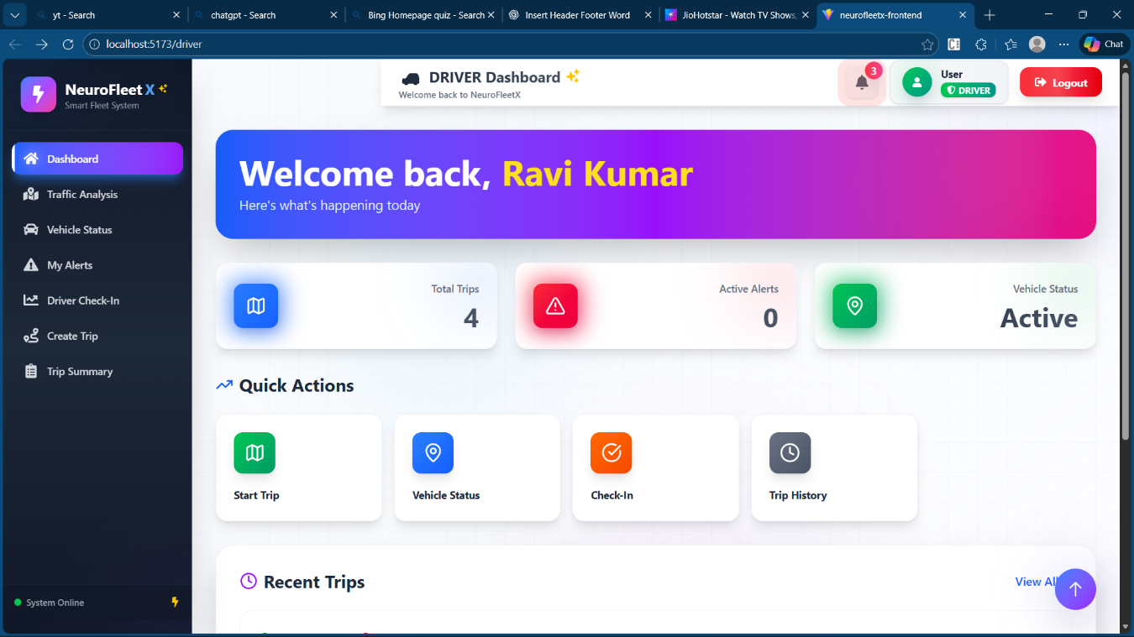
Driver Dashboard
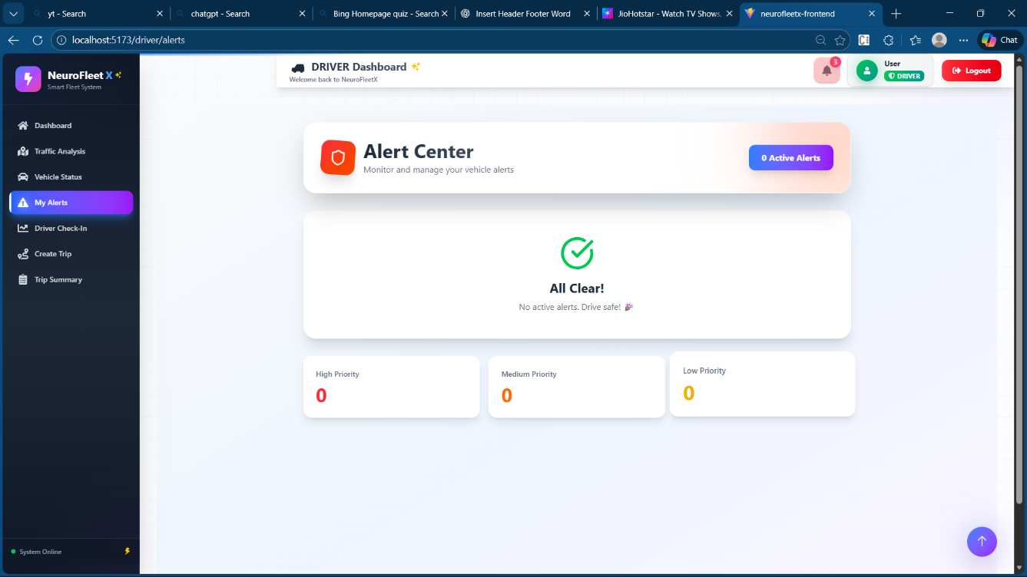
My Alerts

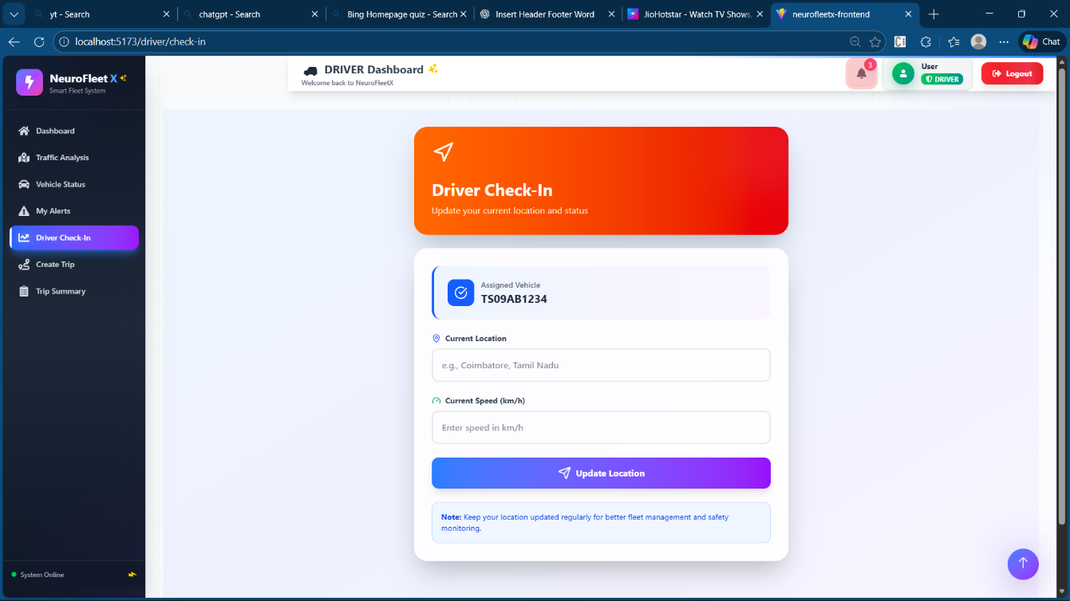
Driver Check-In

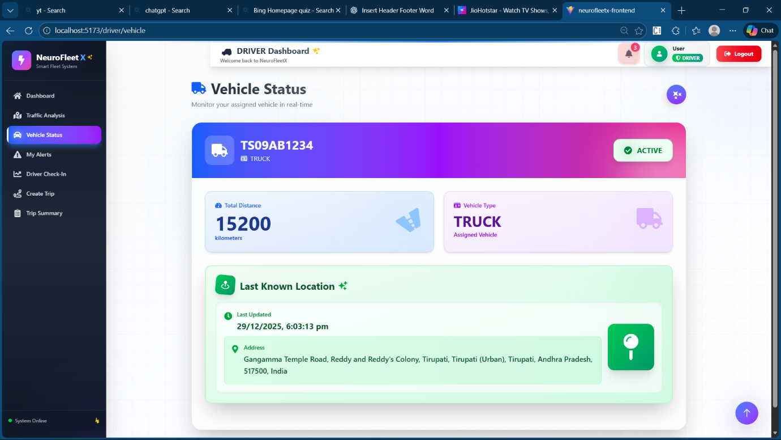
Vehicle Status
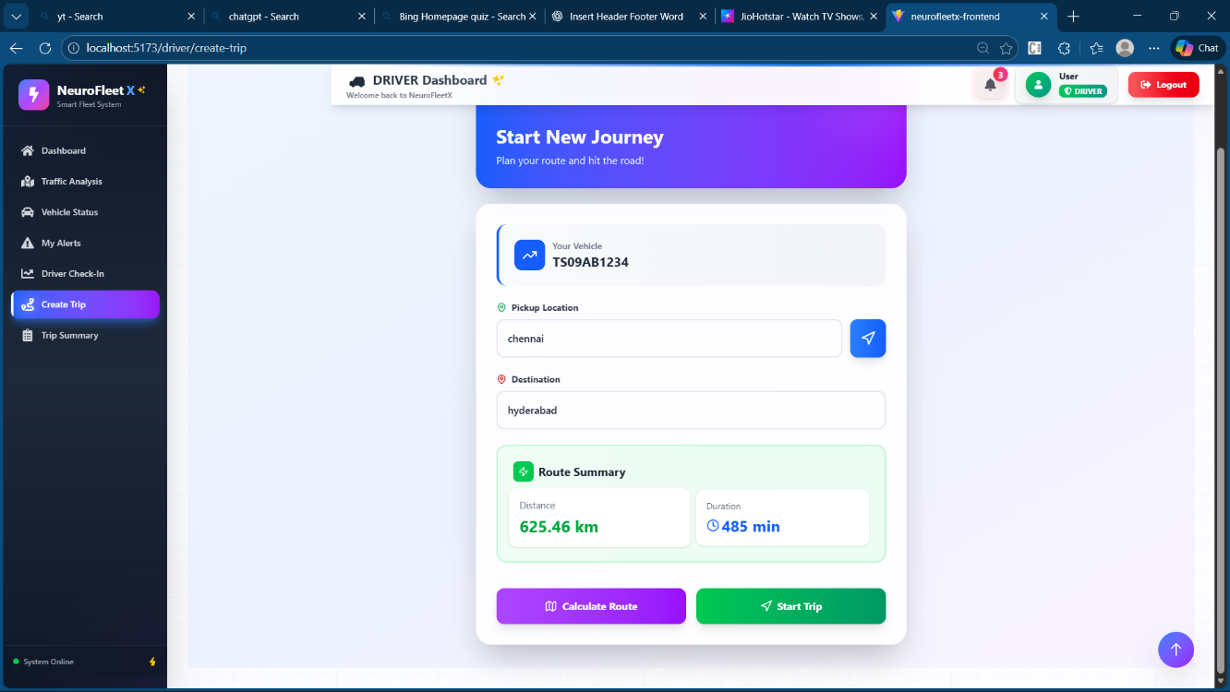

Create Trip

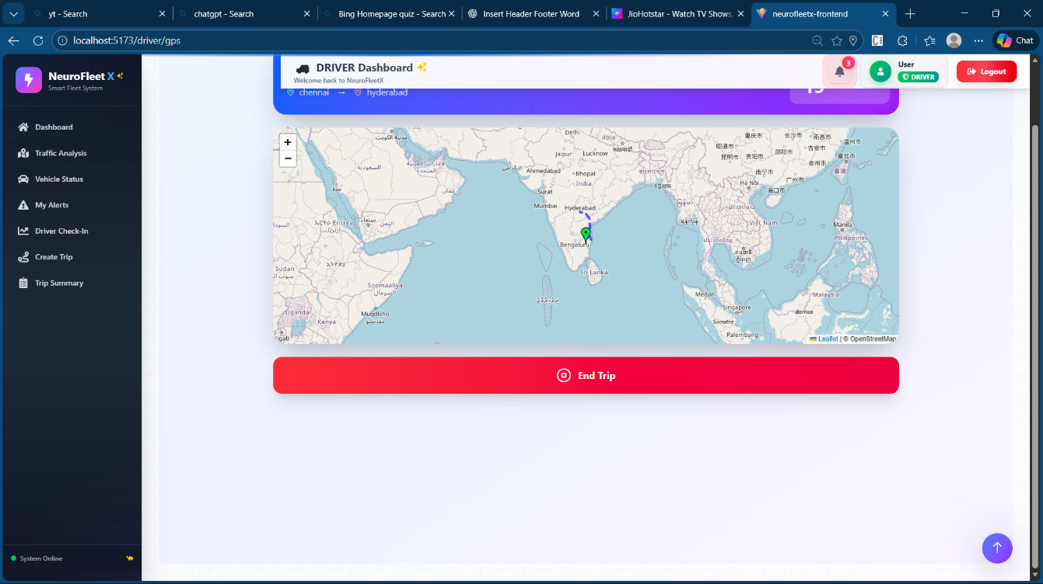

Map to Navigate
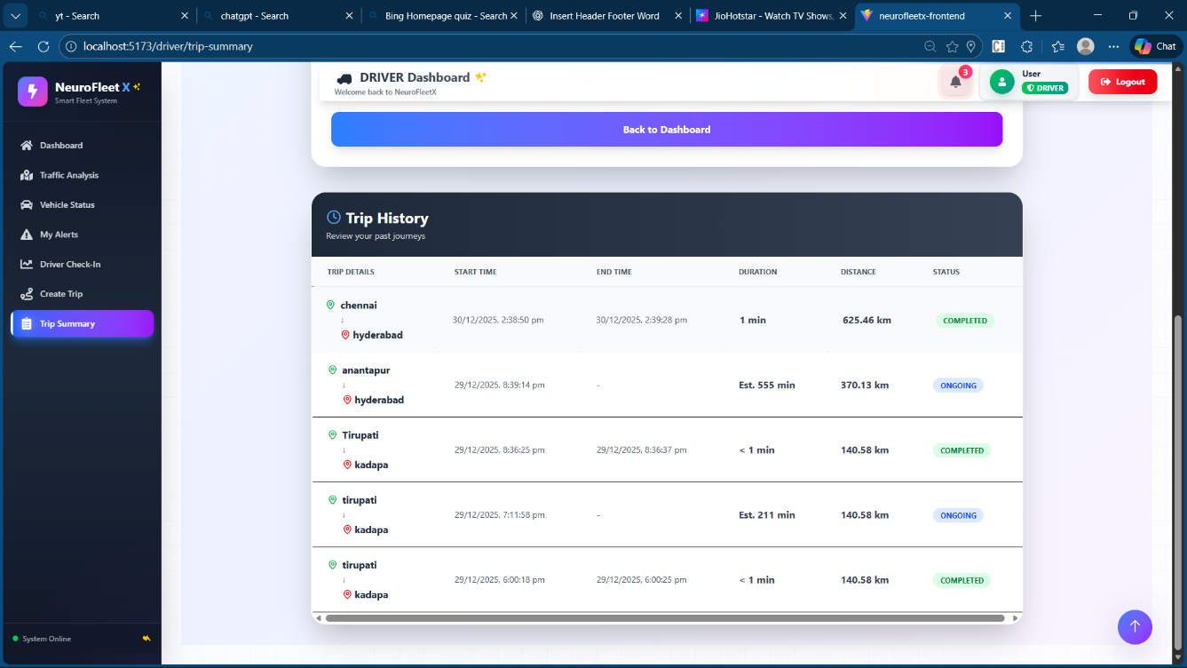
Trip Summary

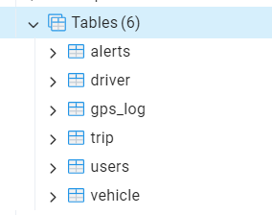
Tables Created in postgress

